ANA 515 Week 5 Visualizations Activity

Gyu Hyun Byun

2022-09-25

## 

## Reading the data into R and Cleaning the Data

## 

The data is read into R, sorted by the variable, total_litres_of_pure_alcohol in reverse order. Then, the data is filtered to focus on the top 10 countries with the highest pure alcohol consumption.

drinks <- read.csv("https://raw.githubusercontent.com/fivethirtyeight/data/50ec9ccfe3aa20f328bfd5e5da584fa5e15efee6/alcohol-consumption/drinks.csv")  
drinks <- drinks[order(-drinks$total_litres_of_pure_alcohol),]  
drinks <- drinks[1:10,]  
drinks$country <- factor(drinks$country, levels = drinks$country[order(-drinks$total_litres_of_pure_alcohol)])

## 

## Visualization #1: Bar Plot

## 

The graph shows the top 10 alcohol consuming countries by their total liters of pure alcohol consumption per person per year.

barplot(main = "Top 10 Alcohol Consuming Countries", height = drinks$total_litres_of_pure_alcohol, names = drinks$country, las=2, border="black", col="white")

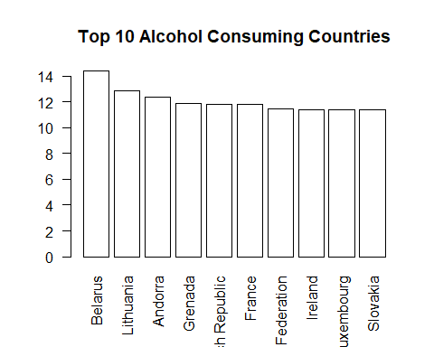

## 

## Visualization #2: GGPlot Geom Bar Graph

## 

The graph shows the top 10 alcohol consuming countries with their wine consumption in RED, beer consumption in YELLOW, and spirit consumption in BLUE.

ggplot(drinks) + geom_bar(aes(x = country, y = beer_servings), stat = "identity", color="yellow", fill=NA, size=2) + geom_bar(aes(x = country, y = spirit_servings), stat = "identity", color="blue", fill=NA, size=2) + geom_bar(aes(x = country, y = wine_servings), stat = "identity", color="red", fill=NA, size=2) + theme(axis.text.x=element_text(angle=90,hjust=1,vjust=0.5)) + labs(title="Top 10 Alcohol Consuming Countries by Drink Type", x = "Country", y = "Consumption")

